Truth and Its Divine Protection Plan – Part III

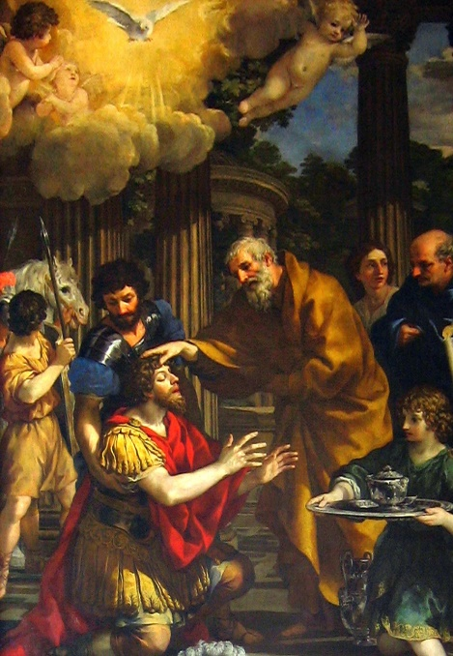
In my previous posts I have shown how we see in the Bible that through Christ we are given the fullness of God’s revealed truths. Jesus taught us these truths in words and deeds when He walked on this earth almost 2000 years ago. Jesus then handed these truths on to the 12 Apostles and gave the Apostles the gift of the Holy Spirit who would guarantee that they would know all these truths Christ wanted them to know in order to hand them on to others. The Apostles then appointed their own successors – the bishops – and to these successors the Apostles entrusted these truths of Christ and handed on this gift of the Holy Spirit through the laying on of hands (ordination). These bishops – these successors of the Apostles – continued to protect, preserve and pass on these truths of Christ throughout the world and to all generations. Those men called bishops today in the Catholic/Orthodox Church ARE the successors of the Apostles. There is an unbroken line from these Catholic/Orthodox bishops today to the 12 Apostles.

The clearest and best example of this is the bishop of Rome – the pope of the Catholic Church. Pope Frances is the 265th successor of St. Peter and can trace his lineage all the way back to the Apostle St. Peter himself! [To see the entire lineage all the way back to St. Peter = http://www.newadvent.org/cathen/12272b.htm ]

This understanding of what is referred to as Apostolic Succession was established by Christ Himself in order to protect the fullness of truths that He came to reveal.

But that still leaves the question:
How is it that we can KNOW where to find these bishops who are successors of the Apostles? There are many outside of the Catholic/Orthodox Churches who claim to be “bishops”. Are they truly successors of the Apostles? Some claim to be – how can we know? We need to be able to identify the TRUE successors of the Apostles. How is this possible?
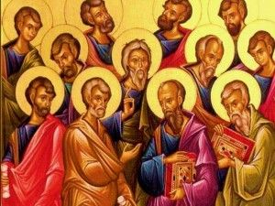
The answer is that Apostolic Succession is not the only protection for His truths that Christ provided! Apostolic Succession ensures that we can trace the source of our doctrines back to Christ through the Apostles, but Christ also established something greater that encompasses the Apostles and bishops. What is this “something greater”?

This something greater is:
The thing Christ gave us to be THE foundation of all truth.
The thing Christ establish – beyond Apostolic Succession – in order to make the “wisdom of God” known to all.
The thing Christ provided to be the means for us Christians to settle disputes about doctrine or interpretations of Scripture and to settle issues with our brothers/sisters.

And what is this “thing” I am referring to? Scripture gives us the answer. It is the Church.

1 Tim 3:15: “If I am delayed, you may know how one ought to behave in the household of God, which is the Church of the living God, the pillar and bulwark of the truth.”

Eph 3:10: “…that through the Church the manifold wisdom of God might now be made known…”

Matt 18:15-17: “If your brother sins against you, go and tell him his fault…if he does not listen, take one or two others…if he refuses to listen to them, tell it to the Church; and if he refuses to listen even to the Church, let him be to you as a Gentile and a tax collector…”

(Additional reference: Acts 15 – leaders in the Church meet to settle disputes about doctrine and practice among the Christians; the answer to the disputes discussed at the Council in Jerusalem are found not in the Old Testament Scriptures but through Revelation given directly to Peter and the others at the Council.)

And what is “The Church”?

Eph 2:19-22 = the Bible gives us an analogy for the Church as being the “household of God” and within this house are all those united to Christ. Christ is the cornerstone of this household and the foundation are the apostles and prophets.

Col 1:18; Eph 5:23; 1 Cor 12:12 = the Bible also tells us that the Church is the Body of Christ; Christ is the Head and the Church including all of her members are His Body. (Thus, the members of the Church are all those united to Christ.)

Matt 5:14 = the disciples of Christ (those within the Church) are lights to the world; and Jesus says that a “city built on a hill cannot be hidden” (what city? Analogy of the Church and how the Church is to be a visible beacon leading all to Christ and His truths!)

Finally, the Church is also the seed and the beginning of the Kingdom of God.
Where do we find evidence of the Church being equated to the kingdom of God?

In Jesus’ own words:

Matt 13:24-30 = “the kingdom of heaven may be compared to…” and the parable continues to tell us about the sower who planted good seed in the field. The parable continues that when the wheat grew up, weeds grew up with it. We are told that in this field wheat and weeds exist side by side. Jesus tells us the sower does not want to pull up the weeds for fear of pulling some wheat as well, so they wait until the day of the harvest. This “kingdom of heaven” can NOT be the heaven where the Saints and Angels are in the presence of God because in heaven itself there are no “weeds”! Those in heaven are in the presence of God and they have been made pure and holy. There are no longer sins but only sinners who have been made perfect. So what is this “kingdom of heaven” Jesus refers to?

Matt 13:47-50 = “the kingdom of heaven is like…” and Jesus goes on to describe a net thrown into the sea that gathers fish and then the good and bad fish have to be sorted/separated. And then the bad fish are thrown out. Then Jesus says this is like what will happen on the Last Day when the good and wicked are separated eternally. This “net” of good and bad fish to which Jesus is comparing His kingdom can NOT be the heaven with the Saints and angels in the presence of God because there are no “bad fish” in heaven. What is this kingdom that is like the net with “good and bad fish”?

Matt 18: 23-35 = “the kingdom of heaven may be compared to…” and then we have the parable of the unmerciful servant. We see that in this “kingdom” the king has servants who are not always faithful and must be disciplined. This “kingdom of heaven” referred to here can NOT be the heaven we think of with the Saints (those who have been made perfect) who are in the presence of God Himself. Why? Because no one in heaven itself is unfaithful to the King – to God. What is this kingdom Jesus refers to?

In each of these parables, Jesus tells us of His “kingdom”. He tells us that His kingdom contains “good seed” that is threatened and challenged by “weeds”. His kingdom has servants within it, some who are good and faithful but also there are servants who ultimately are uncharitable and unfaithful. And His kingdom has within it “fish” but some are good and some are bad.

So, the question again, where/what is this kingdom?

This kingdom is Christ’s one true Church that has its beginnings here on earth and is then brought to its fulfillment when all those in communion with this one Church are perfectly united to God.

Still not convinced that the Church is connected to Christ’s Kingdom?

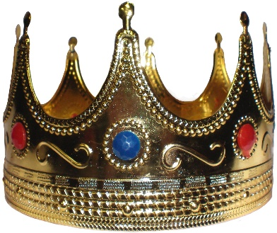
We see in the Gospel of Matthew that Jesus is the Son of David (mentioned many times including Matt 15:22; 20:30). And Matthew tells us that Jesus is the King of the New Davidic Kingdom (Matt 2:2). And there is no king without a kingdom! And Jesus brought the kingdom of David into its fulfillment.
God had promised King David that he would have a son who would be an everlasting king with an everlasting kingdom (2 Sam 7:12-16; Is 9:6-7)! Jesus is this successor God had promised to King David.
Jesus is THE everlasting King and He has an everlasting kingdom!

Then we see in Matthew more on this kingdom:

Matt 16:18 = Jesus tells the Apostle Simon, “I tell you that you are Peter and on this rock I will build my Church and the gates of Hades will not overcome it. I will give you the keys of the kingdom of heaven; whatever you bind on earth will be bound in heaven, and whatever you loose on earth will be loosed in heaven.”

Jesus here shows us that He IS establishing ONE Church.
Jesus here is also giving the Apostle Peter the “keys to the kingdom of heaven”, and Jesus tells Peter this kingdom is connected both to heaven itself and here on earth.
Jesus also tells us that this kingdom – His one Church – is built on a rock and we know Jesus is a wise builder such that the house he builds on a rock will not fall (recall Matt 7: 24-29).
Jesus also tells us that the gates of hell will never prevail against His Church!

And understanding that Jesus’ Kingdom is the fulfillment of the Davidic Kingdom, we can also appreciate something even deeper being shown to us here in Matt 16:18.

Let’s look back at the Kingdom of David:

We are shown in the Old Testament that the Davidic Kingdom had a king, and, in fact, David was a priest-king. We see that this kingdom also had a Queen – the queen was always the mother of the king. (When King Solomon ruled, his mother Bathsheba was Queen [1 Kings 2:20].) In the Davidic kingdom there were also 12 officers chosen [we see this with King Solomon [1 Kings 4:7].) The kingdom also had the office of prime minister (Is 22:22).

With Christ, we see the Davidic Kingdom brought to fulfillment. Jesus is the new Son of David. Jesus is the everlasting king with an everlasting kingdom. Jesus is a priest-king. The Queen Mother of the new kingdom is Mary, Jesus’ mother. Jesus also chose 12 men – the Apostles – to be leaders in this new kingdom.

Did Jesus choose a prime minister? The reasonable answer would be yes since Jesus fulfilled the Davidic kingdom as far as the other roles. So who is the prime minister?

First, what do we know about the prime minister based on the Old Testament?
In various places in the Old Testament we are told that the role of the prime minister was to be the king’s “right hand man” in a sense. Additionally, if the king had to be away from his kingdom for any length of time, the prime minister would be in charge of the kingdom until the king returned.

Specific episode related to the prime minister of the Davidic Kingdom:

Is 22:22 =
At this period of time, Shebna was the prime minister of the Kingdom of David but God had found him to be unworthy. The prophet Isaiah then writes that God was going to depose Shebna from his office in the kingdom of David and replace him with Eliakim. As the new prime minister of the kingdom God says regarding Eliakim:
“I will clothe him with your robe and fasten your sash around him and hand your authority over to him. He will be a father to those who live in Jerusalem and to the people of Judah. I will place on his shoulder the key to the house of David; what he opens no one can shut, and what he shuts no one can open. I will drive him like a peg into a firm place; he will become a seat of honor for the house of his father…”

Here we see that the prime minister was given “the keys to the kingdom” and, with these keys, the prime minister could “open” and “shut” doors of the kingdom. This was to indicate the role of authority the prime minister had in the kingdom. When the king was away, the prime minister could make laws or discipline those in the kingdom with the king’s authority to do so.

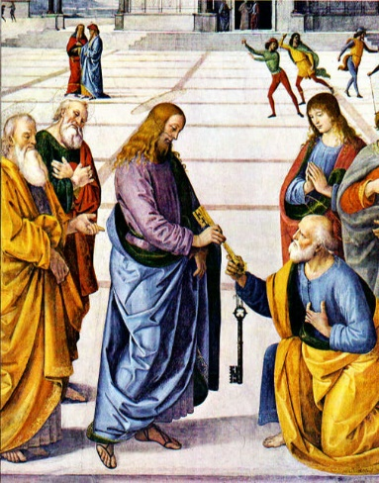
Understanding this, let us look back at Matt 16:18.
Jesus tells Peter He is giving Peter the “keys to the kingdom of heaven” and that with these keys Peter will have the authority to “bind” and “loose”. [The terms “binding” and “loosing” are similar to the terms “opening” and “shutting” and refer to the authority to make laws and administer disciplinary action.]
So what is Jesus indicating to Peter as to the role that Peter will have in Jesus’ kingdom the Church?

Jesus is fulfilling the role of prime minister in the Davidic Kingdom through Peter. So when King Jesus must leave His earthly kingdom for a time (at the Ascension), the prime minister will then assume a leadership role in Jesus’ kingdom.

And this is what we see happening! After Jesus’ Ascension, Peter gathers the disciples together and it is Peter who then instructs the Apostles to elect a successor to Judas (Acts 1:15-26). Then after Pentecost, it is Peter we see who first stands up to proclaim the good news of Jesus Christ (Acts 2:14-41). Peter will be the first to perform a miracle after Pentecost (Acts 3:1-10). Peter received the Revelation from God that the Church is to be open to all people, Jew and Gentile (Acts 10:9-49). After Paul’s conversion when he is beginning his ministry, Paul ensures that he travels to Jerusalem to confer with Peter (Gal 1:18). Peter excommunicates the first heretic Simon Magus (Acts 8:9-24). Peter inflicts the first punishment (Acts 5:1-11).

Jesus establishes a kingdom. His one true Church is the earthly aspect of this kingdom. Jesus is the King. Peter is His prime minister.
The other Apostles are also given authority in this kingdom because in Matt 18:18 all of the Apostles with Peter are given the authority to “bind” and “loose” in Jesus’ kingdom. However, it is only Peter who was given the “keys to the kingdom” giving Peter a unique place.

Jesus’ Divine Protection Plan

We see that Jesus established His Church. He is the cornerstone, He is the foundation. The Church is the Body of Christ. It is God’s household. The Church is also the beginning of Christ’s Kingdom. In this Kingdom, Jesus is King. Peter is the appointed prime minister and the Apostles also have a unique leadership role. Within this kingdom there are intermixed faithful and unfaithful servants who will be separated on the Last Day but until then, all are called to strive for holiness and faithful to the King.

The Church has been built by Christ the wise builder on a rock. The Church will not fall and will be victorious over the kingdom of hell.
This Church is to be the visible beacon of light to lead those in the world to Christ.
Within this Church are the Apostles and their successors who are united to Christ, and these men are leaders in the Church with their duty being one of service. As leaders they are to be the servants of all of the flock of Christ. Of the Apostles, Peter was chosen by Christ to hold the role of prime minister and this office was handed down to all of Peter’s successors (the bishops of Rome / the popes). Peter and the Apostles were to preach Christ’s truths to all nations. This mission was to be continued by all Christians and in a special way by the successors of the Apostles – the bishops.

Jesus has promised the Apostles and as such the Church that He and the Holy Spirit will be with them always.
The Holy Spirit was also given to the Apostles so that they would be able to know ALL truths. These Apostles handed on these truths to their successors the bishops. The pope – the successor of Peter – united with all of the bishops of the Church throughout the world are the leaders of Christ’s Church even today and they continue to faithfully hand down the truths of Christ to all generations with the protection of the Holy Spirit.

And where is this one true Church of Christ? Where is the Church that has the bishops who are successors of the Apostles and specifically the successor of St. Peter himself?

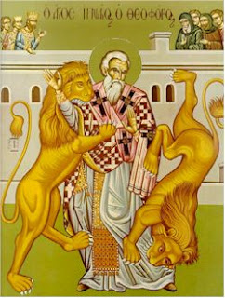
This one true Church of Christ is the Catholic Church.

And we can look back to the earliest Christians that shows this. Bishop Ignatius of Antioch, in 107 AD, wrote:
“See that you all follow the bishop, even as Jesus Christ does the Father, and the presbytery as you would the apostles; and reverence the deacons as being the institution of God. Let no man do anything connected with the Church without the bishop…Wherever the bishop shall appear, there let the multitude of the people also be; even as wherever Jesus Christ is, there is the Catholic Church.” (Letter to the Smyrnaeans, Ch.8)

Please join in the conversation with questions/comments on Facebook – Allison Tobola Low.

