Truth and It’s Divine Protection Plan – Part II

So I left off the last post with a question.
Through Jesus Christ we are given the fullness of revelation. How is it that Jesus Christ made it possible for us living 2000 years later to be able to know with certainty the fullness of these truths?
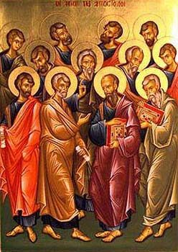
Jesus hands on these truths through His words and His deeds to the Apostles. Jesus also gives the Apostles the Holy Spirit in a unique way – the Holy Spirit enables these men to be able to remember all that Jesus had taught and to be guided into all truth.

The Apostles then preach and teach spreading these truths throughout the known world. As they do this they form local church communities who are all united to Christ and His truths through the Apostles. The Apostles teach these truths orally though eventually some of these truths are written down as well (forming the New Testament).

It is important to note here what it meant to be an Apostle.
These men were chosen by Christ and had been with Christ from the beginning of His ministry. Christ chose His Apostles and then sent them out, “Go into the world and preach the Gospel” (Mark 16:15). [The word “Apostle” means one who is “sent forth”.] Jesus also told the Apostles – related to their preaching and teaching: “He who hears you hears Me, he who rejects you rejects Me” (Luke 10:16). Jesus told them, “I will be with you always” (Matt 28:20). These men knew their mission and knew that they had divine protection and guidance.

But there is something even more than this to be acknowledged. We see this in Acts 1:20. After Judas had betrayed Jesus and then committed suicide, the Apostles gather together and Peter tells them that they need to choose a successor for Judas: “Let his office [bishopric] another one take.” Matthias is then chosen to replace Judas.
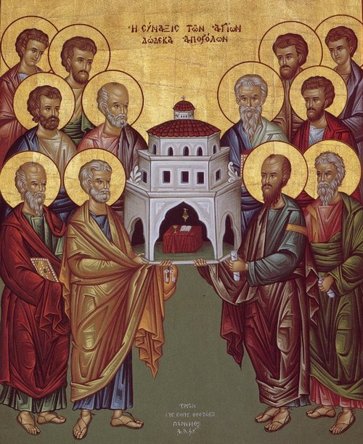
What is a “bishopric” that is referenced here in Acts 1:20? “Bishopric” means the “office of an overseer”. The Apostles are overseers of Christ’s flock. They have a leadership role among the disciples of Jesus. They are to preach and teach. They are to help bring the truths of Christ to the world and offer salvation through Christ to the world. This office was not held by everyone nor was it held by just anyone. And what we see with Matthias replacing Judas is that this office of an Apostle was an office of succession. When one office is vacant, another qualified man is chosen to fill the office.

In the beginning as the Apostles were spreading the gospel, the number of Christian communities as well as the number of Christians within these communities were becoming more numerous. We will then see that the Apostles will chose other men, outside of the 12 Apostles, to be their successors to be in charge of protecting and passing on Christ’s Church. These men were called bishops (episkopos). “Bishop” means an “overseer”. These bishops were continue the work and mission of the Apostles. As successors of the Apostles, the bishops were to be overseers of Christ’s flock here on earth, and they were to go out and preach and teach.

We can see the appointment of bishops throughout the New Testament. One example is Paul ordaining Titus as Bishop and sending him to Crete. Paul tells Titus that one of his roles as bishop was to rebuke those who were insubordinate or who were deceivers (Titus 1:13) as well as to teach sound doctrine and call men to live virtuously (Titus 2:1-6). The bishops were also to instruct by words as well as by being models of holiness (Titus 2:7-8). Paul also tells Titus that one of the things he was to do in Crete was to find other worthy men whom he too could appoint as bishops. Paul then lists some of the criteria for bishops (see Titus 1:5-9). This is just one example where we are given some details about the role of bishops in the New Testament.

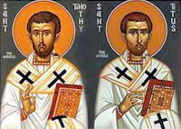
And we are also shown that these bishops chosen by the Apostles were also seen to hold a God-given office. We see this in Acts 20:28 particularly when Paul says to the church elders: “take heed to yourselves and to all the flock in which the Holy Spirit has made you bishops (episkopos) to feed the church of the Lord which He obtained with His blood.” Paul tells us that he became a “minister according to the divine office” and that his mission was “to make the word of God fully known” (Col 1:25). Only men worthy of the role of bishop were to be chosen (and we see this in 1 Timothy 3:1-7), and they were expected to fulfill their duties sacrificing all for Christ and His flock (2 Tim 4:1-6).

Summary to this Point:

Jesus Christ 12 Apostles (Judas eventually replaced by Matthias) As Gospel preached and Church grows Peter and the other 11 Apostles ordain bishops (Successors of the Apostles) Bishops will continue ordaining other men to be bishops and their successors

It was through this process that the revealed truths of Christ were handed down and through the act of laying on of hands, the unique gift of the Holy Spirit that had been given to the Apostles in order to preserve and protect these truths was also handed down to their successors.

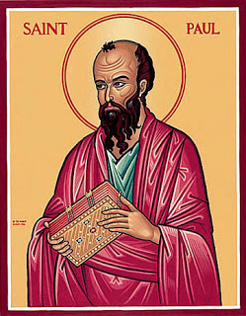
We see that Paul recognized that as bishop he had been entrusted with the truths of Christ. Paul tells Bishop Timothy, “guard the truth that has been entrusted to you by the Holy Spirit who dwells within us” (2 Tim 1:12-14). Paul later tells Timothy, “what you have heard from me before many witnesses, entrust to faithful men who will be able to teach others also” (2 Tim 2:2). We can see in this an acknowledgement that the same gift of the Holy Spirit given to the Apostles by Christ – the gift of the Holy Spirit protecting and preserving the truths – was also given to their successors – the bishops. As bishops they were also now to protect, preserve and hand down these truths of Christ. And we see Bishop Paul handed these truths to Bishop Timothy who was then expected to find other faithful men (to be bishops) so that they too could preserve and hand down these truths.

Do we have other evidence that this is what happened and that this is one of the means Christ established to protect and hand down truths? Yes!

We can look to the writings that we have from Christians that lived in the first and second century. Their writings are not inspired and are not included in the Bible but their writings are very important. They show us how it is that the early Christians were living and what they believed. (You may hear these writings referred to as the “writings of the Early Church Fathers”.)

We can look at writings in this time period and see some amazing details about the early Church that continued to live on even after the death of the last Apostle John.

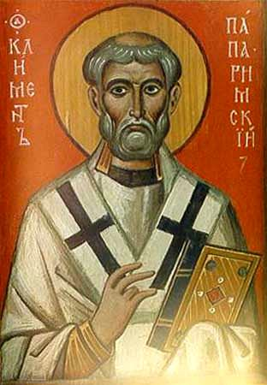
First let us look at the writings from a man who lived in the late first century. He was a bishop of Rome (the third successor of St. Peter as bishop of Rome). His name was Clement I. He shows us that even around 80 AD there was an understanding of apostolic succession already appreciated. In this letter from 80 AD he wrote:

"Through countryside and city [the apostles] preached, and they appointed their earliest converts, testing them by the Spirit, to be the bishops and deacons of future believers. . . Our apostles knew through our Lord Jesus Christ that there would be strife for the office of bishop. For this reason, therefore, having received perfect foreknowledge, they appointed those who have already been mentioned and afterwards added the further provision that, if they should die, other approved men should succeed to their ministry" (Letter to the Corinthians 42:4–5, 44:1–3).

We do not have much written by Clement but we can see here, at the end of the first century that the reality of bishops being the successors to the apostles was recognized.

The second person to look at is St. Irenaeus who was a bishop of Lyon, France. He died as a martyr for the faith. Around 180 AD he wrote some letters. In these letters he addresses this same question about truth – how is it that Christians living at his time (180 AD) could KNOW with CERTAINTY those truths that Jesus Christ came to reveal. As there were already heresies and schisms at the time, this was an important question then as it is now.
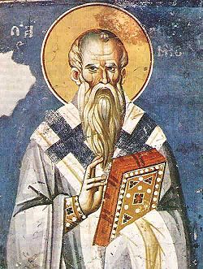
What does Irenaeus say?

“The Church, having received this preaching and this faith, although she is disseminated throughout the whole world, yet guarded it, as if she occupied but one house. She likewise believes these things just as if she had but one soul and one and the same heart; and harmoniously she proclaims them and teaches them and hands them down, as if she possessed but one mouth. For, while the languages of the world are diverse, nevertheless, the authority of the tradition is one and the same.” [Against Heresies, 1:10:2]

“It is possible, then, for everyone in every church, who may wish to know the truth, to contemplate the tradition of the apostles which has been made known to us throughout the whole world. And we are in a position to enumerate those who were instituted bishops by the apostles and their successors down to our own times, men who neither knew nor taught anything like what these heretics rave about…" (Against Heresies, 3:3:1-2).
[And Irenaeus goes on to give a list of all those bishops who had been the successors of St. Peter as bishop of Rome from the time of Peter until the time of Irenaeus.]
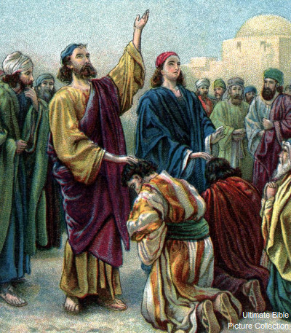
"[I]t is incumbent to obey the presbyters who are in the Church—those who, as I have shown, possess the succession from the apostles; those who, together with the succession of the episcopate, have received the infallible charism of truth, according to the good pleasure of the Father. But [it is also incumbent] to hold in suspicion others who depart from the primitive succession, and assemble themselves together in any place whatsoever, either as heretics of perverse minds, or as schismatics puffed up and self-pleasing, or again as hypocrites, acting thus for the sake of lucre and vainglory. For all these have fallen from the truth" (Against Heresies, 4:26:2).

“We must obey those in the Church who have true succession from the Apostles; for with their episcopal succession they have received the gift of certainty in truth according to God’s holy will. We must suspect all those who are cut off from this original succession, whoever they may be.” [Against Heresies, 4:26]

To summarize Irenaeus’ important teachings from the quotations above, he says that the Church preaches one truth and preaches this one truth throughout the whole world. These truths are the same that were preached by Christ that were handed down from the Apostles. He emphasizes that the way that all of the Christian faithful of his time (in 180 AD) can know with certainty the truths given by Christ was to look to the bishops but only to those bishops who were able to trace their ordination directly to the Apostles. This line of apostolic succession was critical because through this, the gift of the Holy Spirit that Christ gave the Apostles in order to preserve and protect the truth was handed down to these bishops as well. He says that the Christians of his day were to always look specifically to the successors of the Apostles for the truths of Christ. Anyone claiming to be a bishop or leader of the Church who had departed from this line of succession from the Apostles needed to be held in suspicion.

So we can see that this idea of Apostolic Succession has been in existence since the earliest times. Why? Because this is part of Jesus’ plan for protecting and preserving His truths.
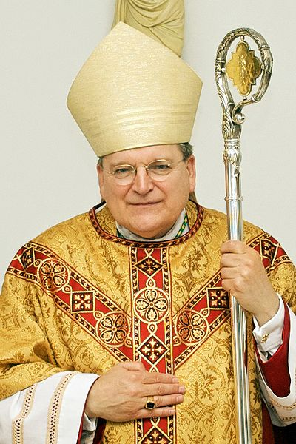
And we still have the Successors of the Apostles today – all Catholic/Orthodox bishops can trace themselves back to the Apostles. As one example of this lineage we can look to the bishop of Rome (“the pope”). Pope Frances is the 265 successor of St. Peter and we can trace a direct line from Pope Frances through all of his previous successors to St. Peter himself.

Just as during the time of Clement and Irenaeus, if we look to the bishops as a whole (the successors of the Apostles) united to the pope (the successor of St. Peter), it is there we can find the fullness of Christ’s truths being handed down to us today almost 2000 years later.

This understanding of how Christ’s revealed truths has been protected and handed down through the Apostles and their successors the bishops is one important component of Christ’s Divine Protection Plan for His truths. But there is more…

I will discuss this more in the next post.

Join in the conversation at my Facebook page – Allison Tobola Low.

