Truth and Authority

Up to this point, anyone who is a Christian will likely agree largely with the contents of my posts. Here is where I anticipate we will begin to see many differences. But as I continue these posts from here on out, I encourage conversations and comments on these posts at my Facebook page (Allison Tobola Low) as long as they are done in charity!

The Nicene Creed shows us some important truths revealed to us by Jesus Christ. However, there were many who called themselves Christians in the 325 AD who disagreed with what was taught in the Nicene Creed. But the leaders of the Church (the bishops) stood up and declared that those teaching anything opposed to the doctrines in the Creed were teaching heresies – their teachings were NOT in accord with what Christ had revealed. Some of the heresies in the early Church were Gnosticism, Arianism, Sabellianism, Montanism and Pelagianism. And this problem of heresy did not simply plague the early Church. People who disagree with certain teachings of Christ or those who debate over what it is that Christ actually taught have continued to rise up over the centuries and even today.

So how do we know which teachings we hear today from various Christians are orthodox (in agreement with what it is that Christ Himself taught) and which are heterodox (not in accord with what Christ taught)?
Where is this Church and its leaders who existed in the 4th century who will stand up and make the determination that someone is teaching a heresy?
And how can we – living 2000 years later – know what truths Christ revealed?
The Nicene Creed gives us a good foundation but it does not answer every question.
How can we answer questions like the following:
*Who wrote the Gospel of Mark? If we do not know, then how can we trust what is written there?

*There is no inspired “table of contents” in the Bible so how do we know how many books are inspired and belong in the Bible?

*There are many different interpretations of the Scriptures by various well-intentioned Christians and all believe THEIR interpretation is the one inspired by the Holy Spirit (and they can support their beliefs with Scripture). Who do we believe?

*Related to the above question, I have heard different views on baptism, on salvation, on grace and on what is meant by “communion” or “celebration of the Lord’s Supper”. I could go talk to a pastor at a Baptist church, Methodist church, Church of Christ church, non-denominational church, or any of the others and get a variety of responses to these doctrines. Who has the true teaching of what Christ taught us about these topics?

*I have heard some say that Christians agree on “the essentials” so that is all that matters. Would Christ agree with us on this? Or would Christ tell us that He has revealed the fullness of truth and we should seek to know all of these truths embracing them all?

*I have heard some Christians tell me that there is no “one group” or “one church” that has ALL of the truths that Christ revealed – all have some truths and some corruptions. But did not Christ teach us clearly in Scripture that He would never let the “gates of hell prevail against His Church” (Matt 16:18)? And if corruptions entered among His Church would that not be admitting that Satan did corrupt Christ’s Church to some degree and that Jesus lied?

I know that God has revealed absolute truths to us and that these truths were given in their fullness through Jesus Christ. I want to know God and love God. I want to deeply encounter Christ more and more every day. And I know that in seeking truth I will find Christ.
And I know that God is love. I know that God is Supreme and perfect. God cannot and would not lie or deceive. So I know that there are answers to the above questions.
I know that God knows us better than we know ourselves. God knows our weaknesses and faults. He knows how easy it is for men to fall into deception or error. I know that God would have provided a way for us to be able to know with certainty THE truths that Jesus Christ revealed. God would not have left any of this to chance or to us men alone!
So what was God’s plan? How is it that the fullness of God’s truths can be known by us 2000 years later?

It is in finding answers to the above questions that led me to embrace the teachings of the Catholic Church.

And now I will explain the foundational reason I embrace the Catholic Church.

Truth and It’s Divine Protection Plan – Part I

All Christians today recognize that the Bible is the Word of God – it is inspired by God and is without error. The difficulty for me though is that if the ONLY thing that we have to reveal God’s truths to us is the Bible then we are still left with questions.
Where did the Bible come from since it did not fall from heaven with all of its various books intact? Why do we trust what is written in the Bible to be the inspired Word of God? The Mormons claim the Book of Mormon is inspired by God and the Muslims claim that the Qur’an is inspired by God. Why do we hold the Bible to actually be inspired and not these other books? And even beyond that, how do we interpret the Bible correctly – the way that God intends?

In contemplating these questions, I have to then ask – how did Jesus intend for all of His truths to be handed down to those of us living today – 2000 years later? What means did Jesus provide for those of us today to be able to KNOW with CERTAINTY all of the truths that He revealed to the Apostles?

To answer this we must begin in the beginning.

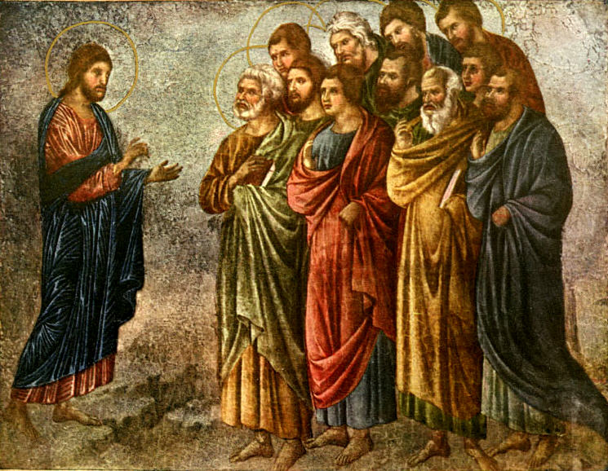
When Jesus Christ – true God and true man – was on this earth, for 3 years Jesus preached and taught. He made God’s truths known through His words and His actions. Jesus gathered 12 men – the Apostles – to be the group of men who had the most intimate relationship with Jesus. Jesus taught these 12 men even more than He taught the average disciple. (We see evidence of this because often after Jesus would teach His disciples and the people in parables He would then later explain the meaning of the parables only to His Apostles.) Jesus was with these 12 men for 3 years. All of these men were witnesses to Jesus from the time Jesus was baptized by John the Baptist to the time of Jesus’ Ascension. (And we can see evidence of this criteria in Acts 1:21 when the Apostles were choosing a successor to replace Judas.)

Jesus taught the Apostles many things. We are told that if all that Jesus had said/done were to have been written down, “the world itself could not contain the books that would be written” (John 21:25). So Jesus taught these men a great deal. And then Jesus commanded these Apostles to go out and preach to the world all that Jesus taught them (Matt 28:19-20).

But before Jesus died, one of the things Jesus did was to promise to give these Apostles a special gift. Jesus knew the weaknesses of our humanity. Jesus knew that it is difficult for us as humans to remember every detail and to be able to hand down all truth without making a mistake. So before Jesus died, He spoke to the Apostles with a promise.

He told the Apostles,
“These things I have spoken to you while I am still with you. But the Counselor (Paraclete) the Holy Spirit, whom the Father will send in my name, He will teach you all things and bring to your remembrance all that I have said to you” (John 14:25-26).

And we also see that even though Jesus had taught the Apostles a great deal, there was still much more that Jesus wanted them to know. Jesus tells the Apostles before He goes to Jerusalem,
“I have yet many things to say to you but you cannot bear them now. When the Spirit of truth comes He will guide you into all the truth…” (John 16:12-13).

So Jesus expected the Apostles to preach the gospel to the world and Jesus ensured that the Apostles had all truth and this truth could be preserved among them.

Another place in Scripture where we see this special gift being promised to the Apostles is in the Gospel of Matthew. In Matt 16:19 we see that Jesus promises to Peter alone, “whatever you bind on earth shall be bound in heaven and whatever you loose on earth shall be loosed in heaven.” Then we see in Matt 18:18 Jesus makes this same promise to Peter and the other 11 Apostles, “whatever you bind on earth shall be bound in heaven and whatever you loose on earth shall be loosed in heaven.” This is a special privilege given only to the Apostles. And the idea of “binding and loosing” was a phrase common to the Jewish rabbis and so the Apostles (being Jewish themselves) would have known that this meant being given the power to make doctrinal and disciplinary decisions.

So we have these key realties – Jesus gives Peter and the Apostles the special gift of “binding and loosing” and also gives them the gift of the Holy Spirit in a special way – to be given ALL truth and to have them be able to remember ALL truth.

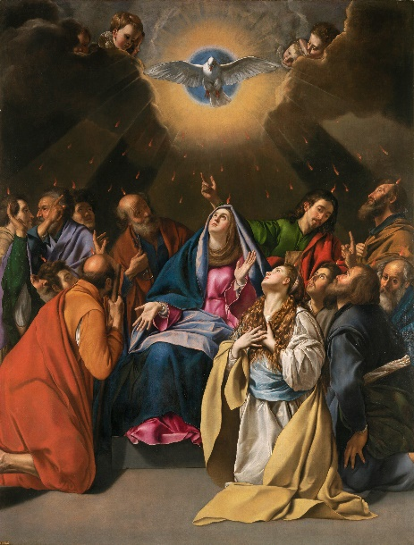
Then what do we see happen after Jesus Ascends into heaven and after Pentecost? We see the Apostles begin to preach and teach. And how do the Apostles first hand down all of these truths and preserve them among the Christians? By writing things down? No. The Apostles hand on these truths orally. The Apostles went all over the known world spreading the Gospel. (We see some description of this in the Acts of the Apostles.)

As the Apostles are preaching and teaching they make many converts to Christianity. They form communities of Christians across the known world and they are all united to Christ through the Apostles. How did the Christians in all of these early Christian communities come to know the truths of Christ? Did they have the New Testament to teach them? Another way to put this, did the early Christians learn from Christ’s Church or from the Bible?

The answer is that they learned from Christ’s Church led by His Apostles. There was no text of what we now call the New Testament that existed for at least 10-20 years after the time of Christ! The early Christians relied on learning from the Apostles and from those men that the Apostles designated to be the leaders of the various local church communities. All of these various church communities were united in faith and united to Christ through the Apostles. And the gospel truths were spread throughout the known world through oral teaching and preaching.

We can see the reality of this even once some of the letters of the New Testament begin to be written. Some of the earliest writings of the New Testament are St. Paul’s letter to the Thessalonians.

In the first letter, Paul emphasizes to the Christians in Thessalonica that what Paul taught them orally was the Word of God:
“When you received the Word of God which you heard from us, you accepted it as what it really was, the Word of God” (1 Thess 2:13).

Paul also emphasizes to these Christians that they are to firmly believe in all of the things Paul and the Apostles have taught them orally as well as what they have received from them in written form:
“stand firm and hold fast to the traditions which you were taught by us either by word or by letter” (2 Thess 2:15).
Finally, Paul cautions them because there were already those preaching heresy – there were those who were spreading a false gospel. Paul writes,
“keep away from any brother who is…not in accord with the traditions that you received from us” (1 Thess 3:6).
So Paul tells the Christians that they can ensure that they have the true gospel IF what they hear is in accord with what Paul and the Apostles have taught them.

Summary to this point:
*Jesus gives the Apostles the gift of the Holy Spirit such that they are given all truth and so that they can remember all that Jesus taught them. Plus, the Apostles are given the power of “binding and loosing”.
*Jesus sends out the Apostles to preach the gospel to all nations – teaching orally
*The earliest Christians heard the gospel and were taught orally and it was at least 10-20 years (possibly even longer) after the time of Jesus before one word of the writings we now call “The New Testament” was even written down.
*The Christians could know what the true gospel was if they could trace what they were hearing to Paul and the Apostles

With this, what happens after the Apostles all died? What happened to all of the truths the Apostles were given by Jesus?

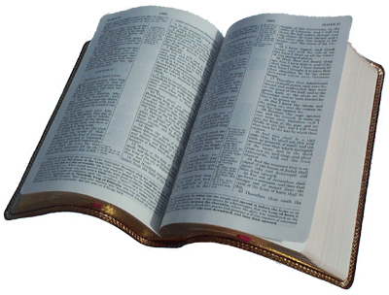
Writings of the New Testament:
It is true that some of these truths from Christ were written down in various gospels and letters that we now have in the New Testament.
But even with this, was everything that Jesus taught able to be written down? No – John 21:25.

And we even see with the early Church, not everything St. Paul taught the Christians was written down (2 Thess 2:15).
And another example is St. John – not everything that he taught was written down either (2 John 12).

Additionally, is the New Testament intended to be a “catechism” – a list of each and every teaching of Christ with an explanation?
No. Much of the New Testament books are letters written by St. Paul to various communities and often Paul is addressing specific issues or concerns – Paul is not intending to give an exhaustive list of Christian beliefs. We also have the Gospels, which were written primarily to give us a testimony of Jesus and His life.

So that leaves the question, how are we to know ALL of the truths that Christ revealed to His Apostles since not everything Jesus taught is written in the New Testament? [And not everything the Apostles handed down to the Christians was written down either – some truths were only taught orally.]

And in addition, even with those truths we do have in the New Testament, how are we to understand what the writers intended to teach us since they have all now died?

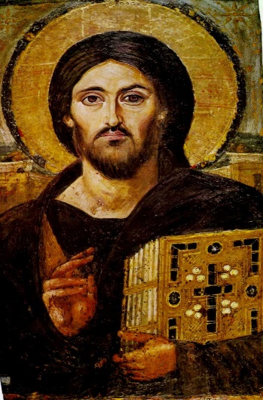
The Good News:
Jesus had a plan.
Jesus promised that He would not leave us orphans (John 14:18) and that He (Jesus) will be with us always (Matt 28:20). In these promises, we can understand Jesus to be telling us that He would not leave His disciples to have to “figure things out for themselves” nor leave His disciples who live 2000 years later with no way to have access to Jesus and His truths. Jesus had a plan. And I will continue with this plan in my next post…

Join in the conversation at my Facebook page – Allison Tobola Low.

