Part V – Revelation: God speaks to men

Revelation is the understanding that God has shown humanity some of who He is. God has done this in several ways.

God Reveals Himself Through Creation

I actually discussed much of this in the last post, but, to summarize, God is the Creator of all things both material and spiritual. Like an artist, God expresses Himself in His creation. Because of this we can examine all created things to learn some about God Himself. Having a finite capacity for understanding, our knowledge of God will always be limited but there are things we can know.

Reviewing some of the attributes we can know about God through creation discussed in the last post, God is pure spirit. He is good, perfect, infinite, eternal and unchanging. God also reveals that He is a personal God. By this it is meant that God thinks, can reason, has a will and has a self-consciousness like all other persons. Additionally, the mere ability to be able to create is an attribute of persons. (Some may argue that animals create: a bird through instinct can build a nest but you will never see the nest expressed in an imaginative way such as in the shape of the Taj Mahal! As such, animals do not create things in this sense.) Because God is personal, He also knows and loves. And all of the good attributes and characteristics expressed imperfectly in the creatures of earth are expressed perfectly in God, which includes beauty, mercy, and justice.

From these revelations through creation, we can also then realize that because God is perfect, God not only knows, He knows all things and knows all things without error – thus, God is truth itself. Because God is perfect, He not only loves but is love itself. Because God is truth we can know He does not lie and therefore when God does reveal Himself to us in more definitive ways (which I will discuss), God can be trusted. Because God is love then we can know that all that God does is out of love. And because of God’s love, we can reason that God would not want His intelligent creatures to not have the means of knowing and loving Him! And this IS the very reason God HAS revealed Himself to us in various ways!

(Of note, the reality of God’s perfect love can sometimes be difficult to believe because of peoples’ experiences of evil and suffering in the world but this is because God’s love and its relationship to evil and suffering are often misunderstood. We will discuss these topics in the future.)

God Communicates Through Human Persons

The next way that God reveals Himself to us is by speaking to us directly as well as indirectly through other human beings. With this form of revelation though we must be very cautious. As human beings we are not perfect. We CAN make mistakes. We can believe something to be true and be wrong. Feelings, emotions, pleasures, desires and various other influences can result in us being misled. We can have a powerful experience and sincerely think we are being moved by the Spirit of God and yet be completely wrong! The reasons for our intellect being prone to error and for our susceptibility to influences will be discussed later BUT we must recognize this reality about ourselves.

Having said that, it is possible for some people to have a true spiritual experience where God moves a person to act. There are also people today who claim to have had visions or other theophanies (visible manifestations of God). However, each of these situations are what we call “private revelations”. Because it is possible for these experiences to be misinterpreted or to be delusions, these experiences must carefully tested. And in all of these cases it can be difficult to prove without a lot of evidence. It is possible for God to communicate to us in these ways but it is also possible for us to be deceived by ourselves, others in the world as well as evil spiritual powers. This does not mean we should doubt these experiences are real but we should be cautious and test everything as to whether it is of God or not.
Another means through which God reveals Himself to us is through our conscience. Cardinal John Henry Newman said that our conscience is a sanctuary where God speaks to us. However, for us to not take this gift of conscience in vain, we must have a “well-formed conscience”. In order to have a “well-formed conscience”, we must actively work to transform our conscience in such a way that our conscience is upright and truthful, able to make judgments based on right reason and using an intellect and will conformed to the will of God. It is possible for our conscience to err and be wrong about a particular situation which is why we have a duty to form (educate) ourselves on the ways of God. (Catechism of the Catholic Church, 1776, 1783-85).
If we have a conscience conformed to the will of God, then within our conscience we can hear God. It then does become our inner sanctuary with God within which we will hear His voice calling us to love and to do what is good and avoid what is evil.

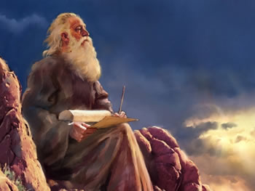
Another way God reveals Himself is using other humans called Prophets. These are men and women whom God gives a special charism (gift) to speak the word of God to others. Prophets do not necessarily foretell the future though they can. God sends them to give a particular message to a particular people, and, at times, God does use these message for more than one purpose. God may admonish, rebuke or encourage the people living at the time of the prophet while also imbedding within those same words a message for future peoples. There have been many prophets of God with some examples being Moses, Isaiah, Jeremiah, Daniel, Ezekiel, Malachi and John the Baptist. Jesus Christ was also a prophet – though He was also much more than that! Jesus will be a topic for a later time, but because in Jesus Christ came the fullness of all that God revealed to humanity, then after the death of the last Apostle, God did not send any further prophets to reveal anything new. There will be no new revelations because all God wished to reveal was made known through Christ.
Now there are still prophets today in the sense that all baptized Christians are called to be prophets to some degree in imitation of Christ. BUT prophets today are called to help make all that God has revealed known more explicitly and to guide others to a better understanding.

God Reveals Himself In the Written Word

There are many different religious groups who, though they differ in the content of faith, believe that because of who God is – wanting to make His truths known to man – God has in some way given us written truths. Religious groups believe this has happened in various ways but there is the consistent acknowledgement of this method of communication between God and men.
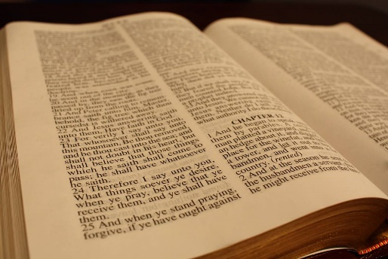
The JudeoChristian view is that, in a mysterious way, God has inspired men to co-author with God these truths in a written form. Jews today believe the written Word of God is found in the “Scriptures” (or what Christians call the “Old Testament”). Christians combine the Jewish Old Testament with additional writings referred to as the “New Testament” and hold all to be the written Word of God. [Among early Jews and among Christians there are differing numbers of total books in the Old Testament viewed as being inspired by God but more on that later.] There are other religious groups who accept the Old Testament and New Testament though with different translations than what the Christians use (the Jehovah Witnesses are an example and have their own translations of the Old and New Testaments created in the 20th century called the New World Translation). The Muslims accept the Old and New Testaments but reject all of the present versions believing these to all have been corrupted. Mormons have additional books/writings which they hold to be inspired by God (such as the Book of Mormon). The Muslims also have the Koran which is held to be inspired by God.

If we put aside the different teachings of these various religious groups, the common belief is that God HAS revealed Himself in an additional way to humanity – in the written Word. Through the written Word, God wants to make Himself known to us. Additionally, by better understanding God our Creator we can also better understand ourselves – particularly the meaning, purpose and ultimate goal of our own lives.

I think there is something to be said about the reality that the majority of those who believe in God believe He has revealed Himself through a written form of communication.
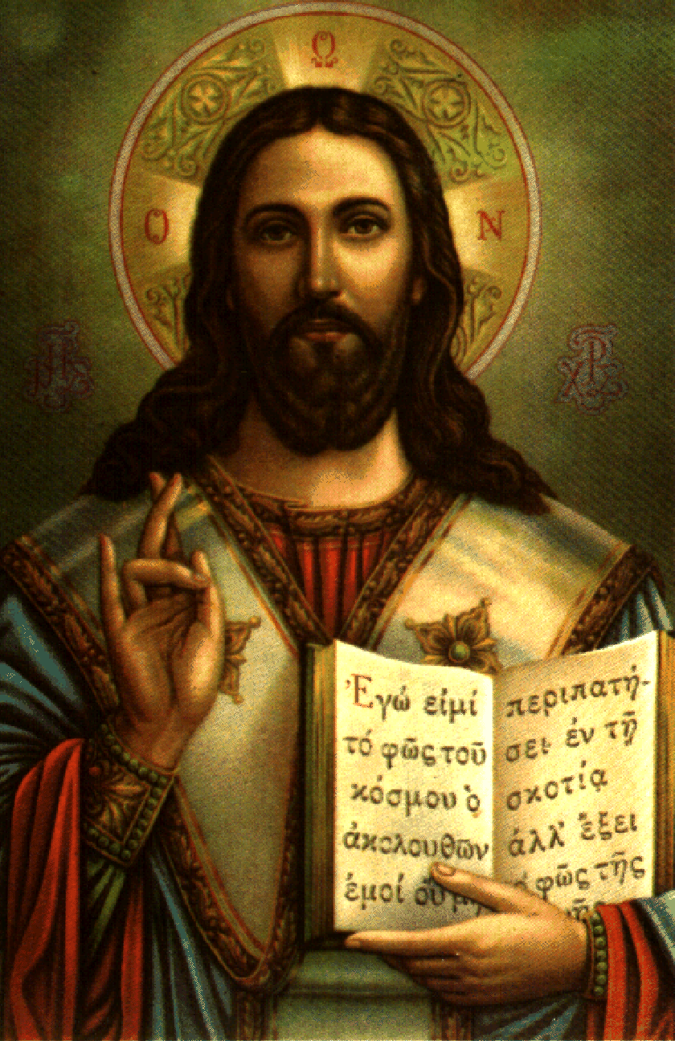
God Reveals Himself Most Fully In Jesus Christ
As Christians, we also recognize that the fullness of truths that God has made known to humanity were given to us through Jesus. Who Jesus is will be discussed later but during His time on earth, all that Jesus did and those things he taught the Apostles were all then handed down to others. At first these teachings of Jesus were passed to others orally. Eventually, some of this was put into writings in what would later be recognized as the New Testament. However, not everything Jesus revealed was able to be written down, so some of His teachings continued to be taught through oral traditions. This will be discussed more in a later post.

In conclusion –
With all of these various ways God reveals Himself to us, the question to me now is not “does God reveal Himself” (because the reasonable answer to me is a resounding yes!), but rather: How can I know God’s truths? How can I better understand all that God has revealed? What is it that God has revealed? What does God show us about Himself as well as humanity? Additionally what comes to my mind is: Who possesses the fullness of these truths revealed to us by God? There are various beliefs and views so where do I find the authentic revelations given to us by God Himself? (And these are only the beginning of the questions we can ask.)

Recognizing these various ways God reveals Himself to us is a sign of love. God loves us so much that He is trying to reach us in a variety of ways. God is calling out to us. God wants us to know Him. God wants us to love Him. BUT because of His unconditional love, God will not force us or coerce us to love Him – God simply waits for our response.

Join in the conversation at my Facebook page (Allison Tobola Low). All comments welcomed!
Up next: Part VI – Faith and Reason.

