Part IV – What do we know about God?

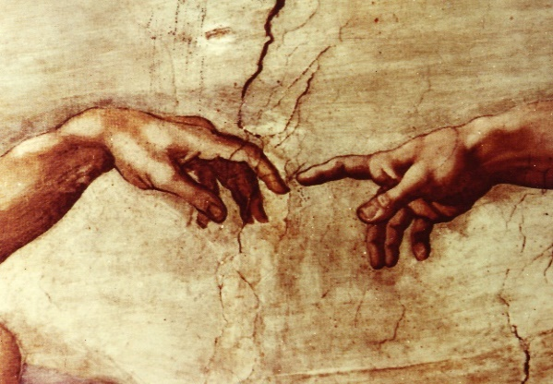
I like to use the analogy of a painter and how we can learn a lot about him by examining his paintings. With God, we can look at creation itself to learn some about the Creator.

Firstly, God is one. The concept of a Supreme Being by definition tells us that there can be no other being greater or more perfect as otherwise he would then not be “the Supreme” being. [And evidence now tells us that the early primitive humans were largely monotheistic contrary to what many today claim so this understanding of one Supreme Being is not a novelty plus it is simply reasonable!]

Next, God is pure spirit. The existence of anything and everything material owes its existence to another. There had to be a Being who is the cause of all other things. This Cause of all other things thus could not be a creature Himself. This Being simply exists. This Being is God. And God therefore cannot be composed of matter since He was not created. Thus God is pure spirit.

God simply IS. From this we can also conclude that God is eternal – God has no beginning and no end. Additionally, because God is pure spirit and is Supreme, God has no limits of space and time; therefore, God is infinite. God has no limits and therefore has no imperfections – God is thus perfect.

Everything that creation possesses comes from the Creator – God – except that only in God are these attributes possessed perfectly. In creatures these attributes are possessed but imperfectly. Therefore, God is all beauty, all goodness, all truth. God also knows, loves, thinks and reasons as we do but, with God, this is all done perfectly such that God is love itself and truth itself. Because God is perfect, God is also therefore unchanging (what is called immutable). This is because God already is perfect, He cannot acquire any more perfections, and if he were to lose a perfection He would no longer be God.

Because God created us, we owe everything we have to God. God gave us our body, our soul, our talents. The source of our existence at this moment is because God wills it. Our existence moment by moment is held in God’s hand. If God were to cease to will us even for an instant we would fall into nothingness. We are completely dependent on God. And it is the recognition of this reality by humanity that causes us to be religious beings. From the earliest times, human beings have practiced religion and worship. There has been great variability but the vast majority of human societies/cultures have acknowledge the existence of a Supreme Being (though some have erred by worshiping more than one Being as God, worship/religion was still viewed as important).

By acknowledging that God exists and that we are completely dependent on Him leads us to see our duty/obligation to give God thanks and praise (worship). Then because we recognize that God is all good and all powerful, this leads us to pray and ask for supplications (for favors). And these actions of worship in giving God thanks and praise, glorifying God and praying to God are what it means to practice religion. And religion is the understanding that we are uniting ourselves (binding ourselves) to God.

The above are conclusions that can be made about God using our human reason alone. Now it is true that throughout history, our human reason has proven to be unreliable. There have been those societies/cultures who misunderstand who God is and who have a corrupted image of God. This is why we see some worshiping creatures such as birds and cows as gods. This is why we see those who believe that God is a material being. There are also some who have a view that God can change His mind and even that God can make mistakes. Some view God as being remote, merely giving us laws and commanding us to obey Him without ever intervening in the world.

These all stem from poor reasoning which we are vulnerable to because we have a finite and imperfect intellect. And because our reasoning can be in error and because humans can be so greatly influenced by others, often human beings in the past had been left with some uncertainty and confusion about who God is. But fortunately over the centuries, great thinkers and philosophers have existed who have been able to use our gift of reason very well and come to the reasonable conclusions that I have discussed above in order for us to better know who God is.
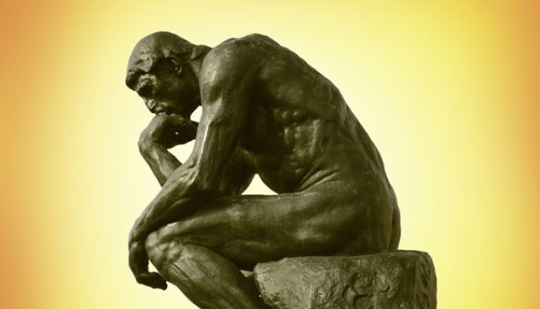
But for some, the question still remains, how do we know for certain which of the various views of God are true? There are philosophers and theologians who differ so who do I trust?

Is there a solution for those who have this dilemma?

The first step is to actually think and ponder – use your own reason to consider the question of who God is because much can be concluded about God through reason alone. Secondly, we can reason further that we do not have to utilize our own fallible reason alone. God has provided even more.

Because God is THE Supreme Being, possessing all perfections, being goodness itself, we can reason that a good God would not want those rational creatures whom He created (us) to be confused about who He is. Additionally, because we can reason that He is perfect in love, and as such is love itself, this too allows us to reason that in love, God would want us to know Him.
Therefore, we can anticipate that God would somehow make known to humanity truths about Himself.

And this is the very thing that God has done – God intervened in the world to help humanity come to know Him better and more accurately. How did God do this? Through Revelation – and in Greek this is the word apokalypsis which means unveiling. God has unveiled Himself to humanity. And there are several ways God has revealed Himself to humanity, and this is the topic for next time.

Join in the conversation at my Facebook page (Allison Tobola Low). All comments welcomed!
Up next: Part V – Revelation: God speaks to men.

