Part III – Does God Exist? Some of the Reasons Why I believe in God:

Creation
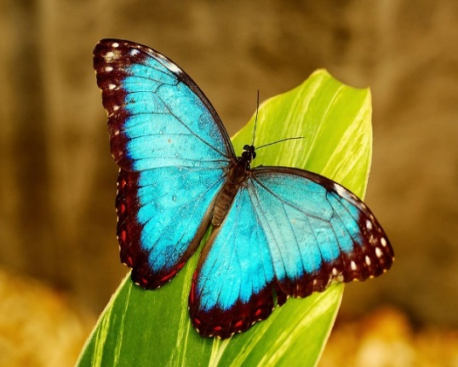
As I look around at the world, from the tiny ants to the butterflies and birds and trees and flowers then to the other fish and animals of the world I have to stand in awe at the beauty of it all. And with everything, there is this complexity yet order. The intricacies of the ant colony and bee colony. The life pattern of a caterpillar who after a period enters a cocoon to only be transformed into a beautiful new form – and why this transformation happens is not fully known but it is remarkable! And we can see the way that all living things have some dependence on each other, both in their own species but also with every other living thing. It is an amazing thing to behold!

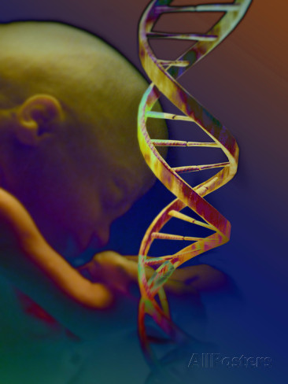
When I was studying in medical school, the classes on human physiology and especially human embryology were incredible. I believed in God but these studies only reaffirmed my faith. The details, order and complexities were mind blowing. Just think of the conception of human life. The egg and sperm contain portions of material that if remain in isolation nothing happens, BUT if they come together and unite, the powerful result is the formation of a new human life! And then in the tiniest cells found at the beginning of human life in the embryo, there is already great activity with cells multiplying and specializing and working together. There is already a blueprint (called DNA) in this person that, if we could understand it at the moment of conception, would tell us all about what will become of this new human life. (And this microscopic strand of DNA with its genetic information is so remarkable that it contains things we are still just trying to comprehend!) Later once this embryo has matured, the microscopic cells that make up the human body are like little machines with various working parts that are essential to the cell and to our entire body to function properly. These cells are also specialized with some that cause our hearts to continue beating, with others that strengthen our bones and other cells that fight infections. And even more amazing is that the human person unlike any other animal has the ability to think, reason, laugh, cry and to recognize the awe of creation.

These living things are all so incredibly complex, ordered and beautiful that the probability of this all being merely because of chance is no longer even a reasonable thought to me. Seeing these things I am certain that there is a God, a Creator, who gives these things beauty and order.

I also look at experiences in my life particularly a recent experience with my loyal companion of 15 years – my dog Hershey. Objectively she was a dog with instincts that she reacted to as she lived her life. Having her for so many years we were able to form such a strong bond and I was blessed to have had her in my life. But the most incredible thing – on her last day on earth she unexpectedly declined in health rapidly. My husband got home before me and noted she was more tired than normal. For the three hours he was home, she simply laid in her bed. I did not get home until late that night, about three hours later than usual. I walked in and immediately noted how tired she looked and that something was wrong. Hershey looked up and acknowledged me. I held her in my arms for 15 minutes and then she rapidly deteriorated dying in the next three hours. It was an incredibly emotional time for me and a painful one as well. However, how is it that this wonderful dog waited for me to get home to die? There is no doubt in my mind that this is what happened. She needed me to be there and I needed to be there with her in this situation. Yes, she is only a dog, yet that is what is so amazing. There was something supernatural about this ability for her to be able to wait for me. I know God had a hand in this.

God’s “Interventions”

I also believe in God because of the miracles that have happened in this world.

Premise 1: I believe it is reasonable that God exists.
Premise 2: It follows that this natural world is not the only reality that exists.
Conclusion: Supernatural experiences like miracles are possible.

Premise 1: Using reason it can be concluded that God is our Creator with an intellect and will*
Premise 2: Reason can then conclude that God is loving*
Conclusion: It is possible for God out of love to intervene in this world (and as such for miracles to happen)
*These conclusions in these two premises will be discussed in the next post

I have never personally experienced a miracle but that does not mean they are not real. A miracle is what some call God intervening in this world. But because God is always present and sustains the existence of this world, it is better to see miracles as moment when God interrupted the natural laws of this world to do something supernatural.

Having said that, I am cautious and often skeptical when I hear stories about various experiences that seem to be supernatural because even though miracles can happen, it is true that people can be deceived or even exaggerate a truth. However, there have been a few cases where people who I know and fully trust have shared stories with me that are unexplainable. These events could not have happened if this world is simply here by chance and if there is no such thing as God. Let me share two of these short stories with you for you to make your own conclusions.
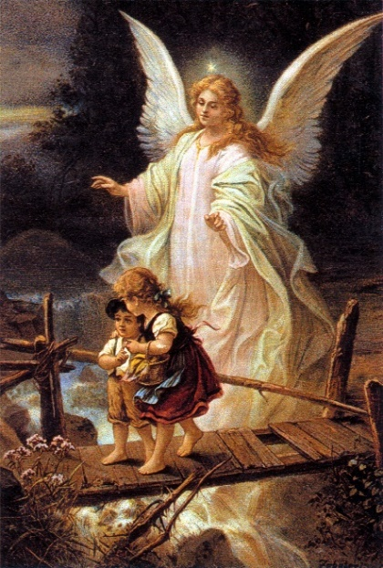
The first is an experience my dad had as a child. He was running across the street coming home from school. He had the right of way to be crossing. However, as he took a few steps off of the curb he suddenly heard this inner voice – “Turn around and run”. He immediately turned back around and ran back onto the sidewalk from where he had come. Within seconds a car had run the red light and collided with an oncoming car. The accident happened in the exact spot where he would have been crossing had he not turned around. His life was saved that day.

Another experience was told to me by a friend. He was close with a family that had two boys and they lived on a ranch. One day they were working and were filling in a ditch with dirt. The dad was alone to do the work though the boys would help intermittently. As the dad was unloading dirt from a trailer attached to his truck, the boys were running and playing. At one point while playing tag, one boy jumped over the trailer hitch as the other brother ran behind the trailer. As this happened, the trailer hitch was accidently kicked loose, the trailer slid away from the truck and rolled over one of the boys. The trailer was too heavy and the dad was not able to lift it to free the boy initially. The dad continued to try to lift the trailer. Eventually there came a moment when the impossible happened – the trailer was lifted just enough to allow the dad to pull the boy free. He was rushed to the hospital. A few days later when the boy awoke from a coma, he overheard his dad retelling the story of what happened to friends. When the dad told of the part of how he lifted the trailer and attributed it to a rush of adrenaline, the boy interjected and said, “No dad, that’s not what happened. Didn’t you see the great big man standing beside you? He lifted the trailer so that you could pull me out.” With no other human person being present at the time, the family knew God had intervened by sending an angel. There was no other explanation.

Morality

I also believe God exists because of morality.

In all of our various cultures on earth now and in the past there exist the ideas of being just and unjust, charitable and uncharitable, respectful and disrespectful, gracious and ungracious, honesty and dishonesty as well as the existence of good and evil and truths and falsehoods. If you agree these concepts exist, how can we explain these concepts if we only existed by chance? If each of us was merely a collection of tissues made up of cells composed of atoms and over millions of years ago random atoms came together by chance to begin life as some argue, how does a moral standard evolve by chance? And there must be some standard or otherwise I could not say one thing is just and another thing unjust. There must be some standard to call one act respectful and another act disrespectful. There must be a truth that does exist if I can call something else a falsehood. To put it simply, one cannot call a line crooked unless he has some idea of what a straight line is.

One may make a counter argument that morality does not prove anything as it is simply the pursuit of goodness and it is “goodness” which determines the standard of right and wrong. But I would ask, if you reject God and simply use reason and nature, WHY pursue goodness? Who says that being good is best for our human species? And then if you do pursue goodness, who determines the standard of what makes one thing “good” and not another? Some may respond by saying that those things which are right and good do not harm others. But who defines what harms another person? For that matter, who defines what a person is?

There are those today who believe that it is more ethical to kill an infant than an adult pig because the pig is more intelligent and more self-aware. There are those today who promote killing a child in their mother’s womb as the mother has the right to decide what is best for her own life and the baby in her womb does not have rights. They argue that if the child is a burden it is moral to kill the child in the womb. There are also those who promote killing those human beings who even after birth cannot contribute to society – those suffering in pain with disease, the disabled, the mentally challenged, etc. There are those who say that these actions are good because it is what benefits society the most. They argue that these people are not benefiting society and a life with these impediments is not worth living. Along those same lines, there are those who say that we should not help the poor or needy in this country or any other because it only weakens the gene pool and increases the amount of suffering in the world by protecting people and communities that are not strong enough or innovative enough to survive on their own. Many would argue from nature and reason that the goal of any species is simply to survive and pass on the best and most adapted genes for the survival of future generations.

Hopefully these thoughts and views above make you cringe as they do me BUT if you do not believe in God, how can you argue against someone who promotes the moral standards above? You can’t.

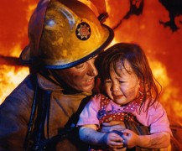
So if you agree with me that there ARE absolute moral standards that exist (there are things just, respectful, honest, intolerant), how are these concepts compatible with the notion of human beings merely arising by chance? The concept of survival of the fittest (that the most adaptable to the conditions survive) is about survival of the individual and of the species. Why then does it bother us that others in the world are starving? Why then do we hold ideas like respect for our neighbor, putting our neighbors’ needs above our own, being humble or the idea of sacrificing for others in the world who need my help as such honorable traits? Why not simply view the poor and homeless as simply unfortunate and victims of chance that we abandon since they are not “the fittest”?

If we look to other animals, we do not see virtue but an instinct to survive. We do not see a squirrel running out into the road to rescue his brother squirrel who has been run over by a car but still hanging on to life. Yet among human beings, a man who runs into a burning building to save a life is regarded as a hero with great virtue.

We do not expect to see a mother robin who spots a baby bird of another robin family trapped in some vines help free the baby. But if we see a baby sitting in a hot car, we will break the windows to save the child and then arrest the mother for abandonment. We have a sense of duty to protect human life and have certain expectation for parents. Do these concepts “evolve” by chance? I find it unreasonable to see anyway that respect, humility, honesty, responsibility and other virtues we hold today could have simply “evolved by chance” – it does not make sense.

And as human beings we hold each other accountable for wrong doing. We do not place a lion on trial for killing a gazelle or for stealing another lion’s food. We do not hold a father duck who has abounded the family accountable to helping to raise his children. For human beings we recognize there is a moral standard that humans are held to because we are different than all of the others in the animal kingdom. We can think and reason. We can know right and wrong and make a choice to freely act one way or another based on our knowledge. This morality is something difficult if not impossible to simply explain with the idea of chance and evolution.

How do we explain our moral values?

Because we do hold there is a moral standard we are expected to live up to and with it being unexplainable how these values could have simply evolved by chance, this indicates we possess these values because we have received them – given to us by someone else. (If you disagree, what is the explanation?)
And then we can reason that “this someone else” who gave us these moral values is our Creator – God.
From the beginning God has placed in the hearts of all men certain absolute moral truths and, when we honestly search our hearts, we will see them. There is a sense of duty to protect innocent life and that intentional killing of innocent life is wrong. There is a sense of kindness and love for our neighbor. A sense that rape is wrong. A inherent desire to seek truth and to do good. And once we acknowledge the existence of God, we will also recognize an inner sense within our hearts to love God, give God thanks and praise and to adore/worship God.

Now it is true that there is evil and wickedness in the world. It is true that many people disregard these moral values that have been given to us. But that does not disprove God. A juvenile who ran away from home does not prove he does not have biological parents. Rather, because the juvenile exists we know he has parents. If this same juvenile breaks the law, this does not prove that his parents neglected to teach him virtue. It is possible his parents poorly lived out their parental responsibility but it is also possible that his parents brought him up very well but he became rebellious because of external influences at school. Similarly with human beings, morality and God.

These are just some of the reasons I believe in God. They may not convince anyone else but I am convinced! Please join in the conversation at my Facebook page: Allison Tobola Low.

Up Next – Part IV: There is a Supreme Being, our Creator. And what is it that we know about God? This is the topic for next time.

