Allison’s Evangelization Corner

There is so much confusion these days when it comes to religion and God. There are growing numbers of people who reject God. There are many who claim to be Christian but do not seem to understand what this fully means. There are disagreements as to what messages Christ taught us which has led to various Christian denominations. There are misunderstandings about what God teaches us about religion and worship. And being Catholic, I have found there are so many misconceptions about what Catholics believe both by non-Catholic Christians as well as by Catholic Christians themselves. I am going to post a series of blog posts over these next several weeks under the title “Evangelization Corner” with different topics each time. I am hoping to address some of this confusion.

With each post, I would love to start a dialogue in the comments section on my Facebook page OR privately in a Facebook message if you want to remain anonymous to the public. (Find me on Facebook: Allison Tobola Low).

Please feel free to post further questions, additional points related to that specific post and constructive criticisms (as I am always looking to work on strengthening my own apologetics). Please keep this charitable! So let’s begin…

Do you believe in God?

More and more people today are either rejecting God or are strongly doubting the existence of God. My first several blog posts are going to be related to this question.

Before I get started, there are so many great resources about this fundamental topic, but if I had to choose three, I would strongly recommend: (1) The Last Superstition by Edward Feser (book) (2) Answering Atheism by Trent Horn (book) (3) Strange Notions (website).

Do you believe in God? To help find an answer to this question, I first would like to start with a wager…

Part I – Life After Death? The Wager:
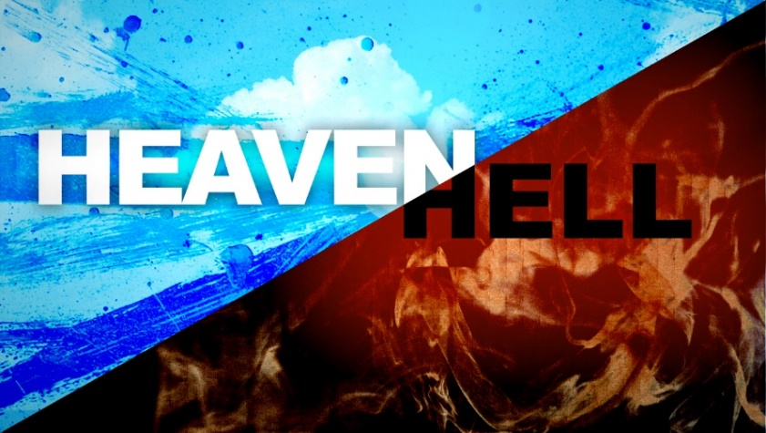
One thing I would like to begin with is what is called Pascal’s wager. I would ask any person today who did not believe in God or who doubted: What is the purpose of our life here on earth? Is it simply to make money, be successful and do whatever it takes to be happy here on earth? Or is there something more, a transcendent purpose – something beyond this earthly life?

Pascal was a 17th century French philosopher who concluded that ultimately we can all agree that there are two possibilities: EITHER (a) There is a purpose for our lives greater than this earthly life and there is something beyond death; OR (b) there is no greater purpose for our lives – we live and die and that is it.
[If choice (a) is the reality then there must be a God/Supreme Being involved with making that possible.]

If the reality is that there is no God and this earthly life is the only thing that matters, if we live and die and there is no more, then it does not matter whether we choose (a) or (b). We can believe in God or not believe in God. We can live however we want. It will not matter in the end. And if a person believes in God but in reality He does not exist then I have lost nothing more than a few temporal pleasures. Oh well.

ON THE OTHER HAND, if the reality is that there IS a God and there IS life after death, then everything that we do in this earthly life DOES matter. And it DOES matter whether or not we choose (a) or (b)! Our choice has eternal consequences!

If we live our life believing that only this earthly life matters and I can live however I want, YET there IS a God that I am rejecting, this WILL have eternal consequences (because God tells us this is the case)! If a person bets everything on choice (b) and rejects God, then he could be losing EVERYTHING for eternity!

Pascal said that in this life we cannot be indifferent because this is a question that impacts our entire life/who we are. We must make a choice in what we believe – either option (a) or option (b). Pascal concluded that because we are waging EVERYTHING on one of these two options, the most reasonable choice is to choose option (a) because to do otherwise is to be risking everything for eternity! [Choosing option (a) if you are wrong you have lost minimal; choosing option (b) if you are wrong has eternal consequences!]

To summarize, at the end of this earthly life when we die, we will either go into nothingness OR we will meet God our Creator. It is one or the other – both cannot be true. If we examine the different religions who believe in one God – one Supreme Being – and who claim to know God’s revelations to us about life after death, the vast majority teach that God our Creator has revealed to us that there WILL BE judgment for every human person based on how they lived their lives on earth. There are some differences in religions about the details about life after death but the vast majority teach that there are good and bad consequences based on your earthly life. The good people are happy and are rewarded, whereas the wicked are punished and suffer miserably. I will discuss variations in religions later but for now the question is either God exists or He does not exist.

If you bet your eternal life on option (b) and choose to live an earthly life however you please as if God does not exist and then at death you find out GOD DOES EXIST, your choice could potentially bring you an eternal life in hell. The emphasis on making a choice is not to coerce belief BUT this fact alone should make us stop and inquire about the reality of whether or not God exists.

There are many proofs of God’s existence that Thomas Aquinas and others discuss BUT before even discussing these proofs, I challenge you to make this wager. Do you choose option (a) or option (b)?

Up next: Part II – Does God Exist? The Proofs.

