Christian Faith

What are the things that all Christians believe?
A great summary of this is found in what is referred to as the Nicene Creed (the full name is actually the Niceno-Constantinopolitan Creed). This was formulated in the 4th century by the Church.

Why was it necessary to define the beliefs of the Church?
After the death of Jesus, the Apostles preached the Gospel to all nations. They then chose leaders to be their successors in various communities around the world. The Apostles and early Christians lived in the Roman Empire. During the second half of the first century the Christians were disliked by the Jews and by the Romans. Ultimately, most of the Apostles and many early Christians were persecuted and killed for their faith. Waves of persecutions continued until the early 4th century. Thousands upon thousands (if not more) Christians were killed for believing in Jesus, for professing the Christian faith and for refusing to worship the emperor and pagan gods of the Roman Empire. During these first 250 years (or so), Christians could not have public assembly and could not fully express their faith thus making it difficult to address heresy on a universal scale. This changed after 312 AD when the Emperor Constantine declared that all religions were to be tolerated, whether one was a pagan or one was a Christian no one would be persecuted based on their religion. This ended the persecutions of the Christians for the most part and now the Christians could publicly profess their faith.

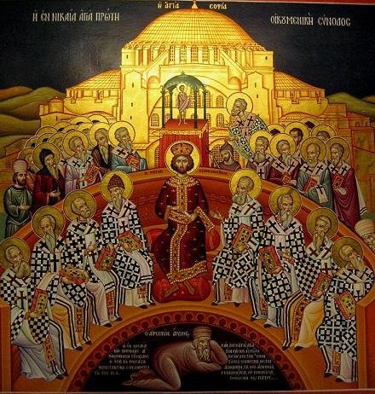
Over the first several hundred years after Christ, there were some people who took all that Jesus had revealed and unfortunately misinterpreted it. Others doubted the authenticity of some teachings and added their own. Some even claimed to have experienced their own private revelations from God thus leading them to emphasize their own teachings rather than those teachings from the bishops of the Church. As a result, many heresies existed. In the early 4th century, now that Christians were no longer persecuted, Christians from all over the world could communicate easier and could even come together to address these heresies.

We see this first happen on a large scale at what is called the Council of Nicaea. Bishops – who were the leaders of the Church throughout the world – came together. Many issues were discussed at this council including various heresies. The bishops wanted to make it explicitly clear what it was that Christians believed. The result of this Council was that the first part of the Nicene Creed was formulated.

I believe in one God, the Father almighty, maker of heaven and earth, of all things visible and invisible.
I believe in one Lord Jesus Christ, the Only Begotten Son of God, born of the Father before all ages. God from God, Light from Light, true God from true God, begotten, not made, consubstantial with the Father; through him all things were made. For us men and for our salvation he came down from heaven, and by the Holy Spirit was incarnate of the Virgin Mary, and became man. For our sake he was crucified under Pontius Pilate, he suffered death and was buried, and rose again on the third day in accordance with the Scriptures. He ascended into heaven and is seated at the right hand of the Father. He will come again in glory to judge the living and the dead and his kingdom will have no end.

There continued to be debates and disagreements among Christians as to various teachings including the role of the Holy Spirit. Thus, another council was called in 381 AD – the Council of Constantinople – to again address heresies that had arisen. At this council, bishops discussed the teachings of Christ and formulated the second part of the Nicene Creed to make it clear what Christians believed.

I believe in the Holy Spirit, the Lord, the giver of life, who proceeds from the Father and the Son, who with the Father and the Son is adored and glorified, who has spoken through the prophets.
I believe in one, holy, catholic and apostolic Church. I confess one Baptism for the forgiveness of sins and I look forward to the resurrection of the dead and the life of the world to come. Amen.

Thus this Creed is technically called the Niceno-Constantinopolitan Creed since the full creed was formulated from two different councils but the name of the creed is often shortened such that it is referred most commonly as simply “The Nicene Creed”.

The Nicene Creed is a great summary of what it is that Christians believe now and have believed for the past 2000 years.

[Other creeds were developed in the early Church as a summary of Christian beliefs. The Nicene Creed is one of the most formal but also look at the Apostles’ Creed or the Athanasian Creed if interested as they too provide good statements about what it is that Christians believe now and have always believed.]
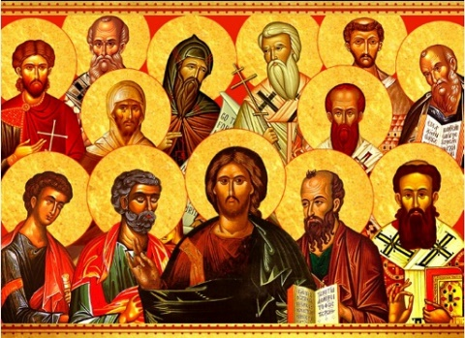
The Nicene Creed is not an exhaustive list of what Christians believe and what God has revealed to us but we can say that ANY belief that goes against what is taught in this creed is a heresy. And these truths proclaimed in the Nicene Creed can be referred to as “dogmas of the Christian faith” which means that these are absolute truths that God has revealed to us. Some of the things we can profess based on these early creeds of Christianity:

*If anyone rejects the teaching of the Trinity – that there is one God and three Divine Persons in the Godhead – their beliefs are opposed to ancient Christian teachings.
*If anyone rejects that Jesus is God – the Second Divine Person of the Godhead – who became man, then their beliefs are opposed to ancient Christian teachings.
*If anyone rejects that God created all things – both in the material world and in the spiritual world – his views are not in accord with what Christians (and Jews) have held from the beginning.
*If anyone rejects the teaching of Jesus being born from the Virgin Mary, their beliefs are contrary to what has clearly been taught by Christians from the very beginning.
*If anyone rejects that Jesus died on the cross for all humanity and then rose from the dead on the third day and then ascended into heaven, their beliefs are opposed to what has been held by Christians from the very beginning.

The truths expressed in the Nicene Creed are a part of our Christian faith. We can know these truths with certainty because God has revealed them to us.

Additional Study Materials:

Do you have specific questions about each of these truths mentioned in the Nicene Creed? Check out these websites for more information:

**Birmingham Catechetical Institute: http://www.bhmci.org/curriculum.html
**Opus Dei: http://www.opusdei.org/en-us/section/summaries-of-catholic-teaching/

**A really good summary breaking down each of the points of the Nicene Creed:
Part I: http://www.stspeterandpaul.net/uploads/7/3/6/1/7361562/the_nicene_creed_february_28_2012.pdf
Part II: http://www.stspeterandpaul.net/uploads/7/3/6/1/7361562/the_nicene_creed_march_13_2012.pdf
Part III: http://www.stspeterandpaul.net/uploads/7/3/6/1/7361562/creed_talk_part_three_march_21_2012.pdf

Join in the conversation at my Facebook page – Allison Tobola Low

