Allison’s Evangelization Corner

Part II – Does God Exist? The Proofs:

Before I discuss arguments/proofs for the existence of God, I want to point out that in our modern world there is so much emphasis placed on science, looking to it for all of the answers about our lives. BUT we have to keep in mind that we cannot prove with absolute certainty that God exists using science. Why? Because science is the study of the NATURAL world and God is supernatural (above nature). God is outside the realm of what it is science investigates. Additionally, science studies those things that are observable. God is invisible and therefore outside the realm of science. But simply because God cannot be proven with science does not mean God does not exist. Science cannot tell us what “love” is yet we have all experienced it. Science cannot tell us about morality and why it is that human beings feel guilty about certain actions unlike animals who perform the same actions merely by instinct without hesitation or emotion. Science is a very important tool we have to understanding our world BUT science does not have ALL of the answers.

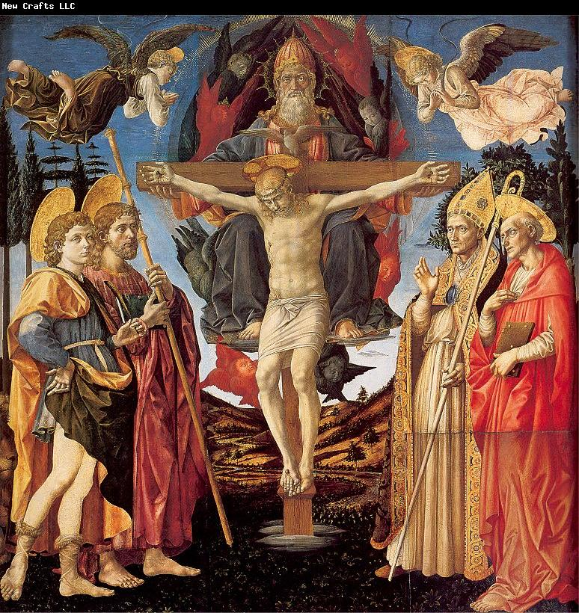
I also want to point out that there are many arguments that show belief in God is very reasonable and these arguments are very convincing to many people. However, there are still atheists and agnostics who are not convinced. Does this mean that these arguments for the existence of God have failed? No. The difficulty with discussing the existence of God is that we are discussing an invisible, supernatural reality. Typically God cannot be observed in our own day to day lives. But more than that, the reality of God is not like a mathematics equation.
The existence of God is profoundly relevant and influential to a person’s understanding of goodness, happiness and purpose of life. One’s belief in God’s existence or rejection of this affects one’s entire outlook on life including how one lives. Because of this, there can be many obstacles to believing in God beyond simply being shown good proofs for God’s existence.

If you do not believe in God or doubt God’s existence, before reading any arguments that show how belief in God is reasonable, ask yourself:
How would it affect your life IF God DOES exist? Would you lose your job? Would it change how you perform your duties at work? Would you have to make difficult changes as to how you live your life? Would it affect your relationship with family/friends? Are any of these changes going to have what you see at this moment as having a bad/negative impact on your life?
Also ask yourself, what are the first reactions I have when I think of a person who believes in God or who believes in religion? What are my attitudes towards people of various faiths? How is it that I view God when I think about the possibility of God being real?

If there are ANY negative outcomes or attitudes that you have related to belief in God, this WILL affect how you view the arguments presented about God’s existence so you must keep that in perspective. I would encourage everyone to put any of these negative emotions/attitudes and issues off to the side for a moment and focus on truth. In living our lives, we need to know the TRUTHS about our lives. If we refuse to look for truth or if we refuse to accept the truths once we find them, we will be living in an illusion and deceiving ourselves and great harm WILL come from this in many ways!

The Evidence and Arguments

Because so many others have come before me to discuss the various proofs for God’s existence, rather than rehash these arguments/proofs, I refer you to many others who have done this more successfully and eloquently than I would be able to do:

Articles
* Dr. Peter Kreeft discusses 19 arguments for the existence of God: http://www.strangenotions.com/god-exists/#12.
*Discussion of just ONE of Thomas Aquinas’ five proofs: http://www.strangenotions.com/unmoved-doubters/ )
*You can also read all of Thomas Aquinas’ five proofs in his Summa Theologica: (http://www.newadvent.org/summa/1002.htm - Article 3).

Books
*My favorites on Atheism:
(1) The Last Superstition by Edward Feser
(2) Answering Atheism by Trent Horn

*Also consider these (though they do not only discuss atheism):
(1) CS Lewis – Miracles or Mere Christianity
(2) GK Chesterton – The Everlasting Man or Orthodoxy
(3) Frank Sheed – Theology and Sanity

*Or check out this book recommendation list: http://www.strangenotions.com/books/

Websites (Two of many good ones on atheism vs. theism):
(1) www.strangenotions.com (2) www.reasonablefaith.org

My Challenge

Rather than discuss the arguments for the existence of God in this post since you can read them on your own through one of the above resources, my challenge is this: I would ask anyone who does not believe in God or who has doubts to do some – if not all! – of the following (I even encourage those who believe in God to take this challenge as well to strength your own faith!):

*Read one or more of the articles/books above and read it slow with serious contemplation

*Pick up a Bible and start by reading the Gospels

*To take a chance and pray to God. Ask God to help you believe or to show you some proof in your life that God does exist. Talk to God about some problems you are having and ask Him to help you. Say to God, “I do not know if you are real but if you are, please give me the gift of faith; please help my unbelief.” Add: “God, I do not know if you are real but I truly need your help; please help me with this difficult situation.” I challenge you to pray every day for a time. What will it hurt? If God is not real there is no harm done. BUT if God is real, He will hear you and you will be surprised at what happens next!

*Finally, listen to other atheists who once were where you are.
Find audio debates between atheists and theists like William Lane Craig.
Read books. Edward Feser was an atheist who later converted to Catholicism; read his book The Last Superstition. Kevin Vost was an atheist and you can read his story in From Atheism to Catholicism. You can also read the story of Jennifer Fulwiler who was an atheist and wrote the book Something Other Than God. Finally, Antony Flew was one of the most famous atheists in the world during the 20th century and before he died he changed his mind. He wrote There Is A God: How the World’s Most Notorious Atheist Changed His Mind.

In Conclusion –

Belief in God is not a view held only by those who are simple-minded or superstitious as some may claim. Belief in God is not something only the ignorant or uneducated hold. Sometimes I hear the claim that atheists are the elite intellectuals. Contrary to what some say today, in reality some of the most brilliant thinkers of the past two millennia believed in God. Consider Augustine and Thomas Aquinas – two of the most brilliant men who ever lived who were also prolific writers so you can see their genius for yourself – both believed in God. Also consider some scientists of the past centuries considered experts in their fields who believed in God: Galileo and Kepler (astronomy), Pascal (hydrostatics), Boyle (chemistry), Newton (calculus), Linnaeus (systematic biology), Faraday (electromagnetics), Cuvier (comparative anatomy), Kelvin (thermodynamics), Lister (antiseptic surgery), and Mendel (genetics). And there are many others.

Theism (belief in God) is very reasonable, and, more than that, it is atheism (rejection of God) that has always been the minority view until recently when we have seen its rise in modernity. For those who do believe in God, know that we sit among a great company of intellectuals who agree with us. For those who do not believe in God, please take my challenge above!

Up next: Part III – Does God Exist? Some of the Reasons Why I believe in God.

Join in the conversation at my Facebook page: Allison Tobola Low!

